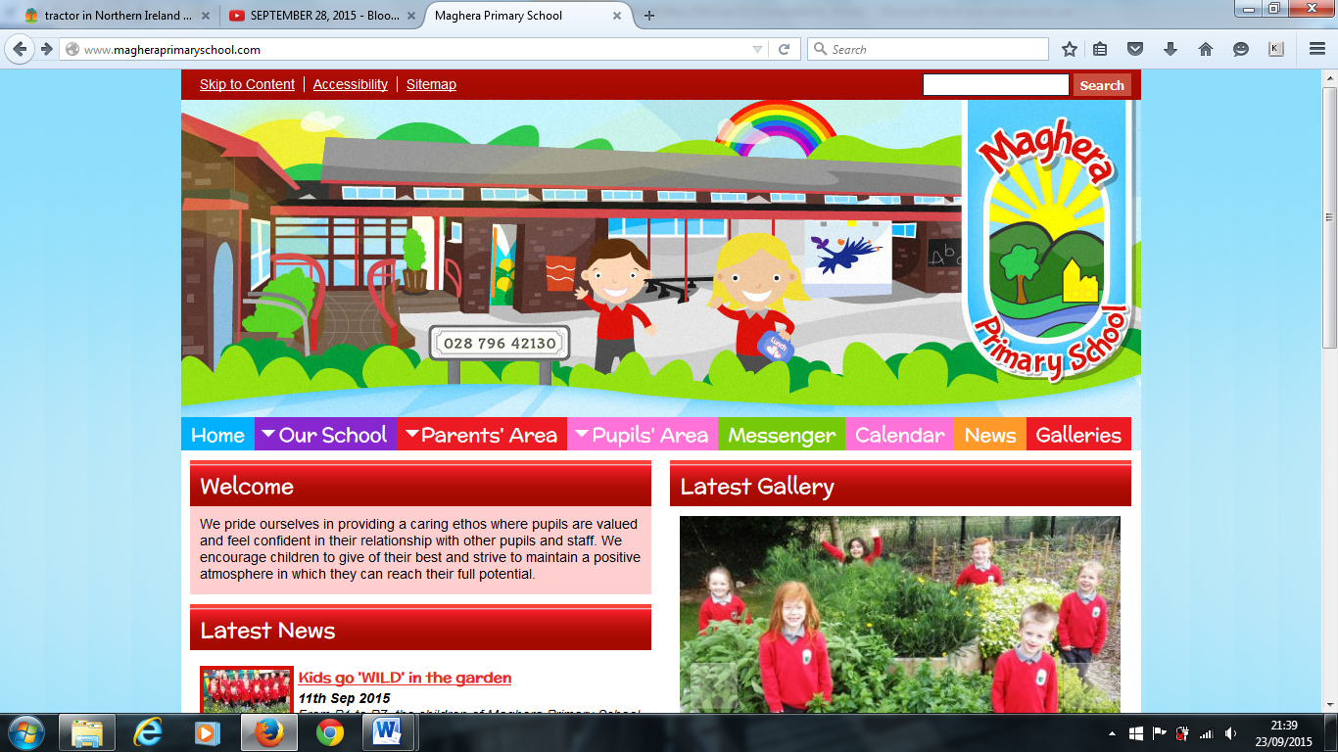

Welcome to our February Newsletter. Here you will find important information about what will be happening in school from Half Term until Easter. If you have any questions, please feel free to contact us by emailing:

[info@magheraps.maghera.ni.sch.uk](mailto:info@magheraps.maghera.ni.sch.uk) or by phoning the school office on 02879642130.

**Holidays**

School will be closed Monday 13th – Friday 17th February 2023 inclusive for Half Term.

School will be closed on Thursday 16th and Friday 17th March 2023.

**Non - Uniform / Party Day**

Friday 10th February is a non - uniform / party day. School finishes at the normal times.

**Parent Teacher Interviews**

The second set of Parent Teacher interviews will take place the week beginning Monday 27th February. All pupils will be finishing school at 1:30 pm on Monday 27th and Tuesday 28th February. There will be no PAL club on these dates.

**Post Primary Applications**

Online applications for a Post Primary Place for September opened on Wednesday 1St February at 12 noon via EA Connect. Applications are open until Thursday 23rd February and are not considered on a first come, first served basis. For more information on the admissions process please visit: [www.eani.org.uk/admissions](http://www.eani.org.uk/admissions)

Please contact the school office if you need any help with your application.

**Cancer Fund for Children**

Thank you to everyone who supported our Cancer Fund for Children Santa Claus Christmas Jumper Day and who donated to the retiring offering at our Carol Service. We have raised £213 for this worthwhile cause!

**After School Activities**

The children are currently enjoying After School Activities on Tuesday and Wednesday. Cookery and Football will continue to run after Half Term. If you haven’t already signed up, get a form from your class teacher and come along and join us !

**Healthy Eating** We are committed to promoting healthy lifestyles in school. We recognise that drinking water has health and educational benefits for everyone. Pupils should only bring in water and no fizzy drinks or juice. Pupils can re-fill their water bottles during the school day.

**Shared Education**

Our Shared Education Programme with St Mary’s Primary School, Glenview is up and running. Primary 4/5 visited Glenview for an icebreaker session on Thursday 9th February. They will complete a further 6 P: E sessions during February and March.

**Morning Arrangements**

8:30 am – 8:50 am is lesson preparation time for teachers and classroom assistants. Parents should not enter school grounds to safeguard pupils. Children should be encouraged to enter school without parental support. Please drop your child off promptly and do not congregate at the school gates. Staff are on duty to supervise the pupils and cannot take messages or money at this time. All money should be sent on a Monday with your child for the week.

If you require to speak to a member of staff, please ring the school office to arrange a suitable time.

**Contact with Staff**

There are times in school life when parents need to talk to a member of staff about a serious concern. When this occurs, please make an appointment with Amanda for before or after school. We appreciate your cooperation in this matter

Maghera Primary School 09.02.23 – www.magheraprimaryschool.com

**Maghera Primary School 25th Sept 2020 www.magheraprimaryschool.com**

**Oct 30**

**Fall Festival**

#### Jan 1

**New Year**

**Feb 2**

**No School**

**Dec 1**

**PTA**

***DIARY DATES***

* Monday 13 to Friday 17 February - Half Term Break
* Thursday 2 March – World Book Day Celebration
* 16 March - School closed for School Development Day
* 17 March - School closed for St Patrick’s Day
* 1st May – First May Bank Holiday
* 8th May – Bank Holiday for King Charles’s Coronation
* 18th May – School closed for Local Council Elections
* 29th May – May Bank Holiday