MAGHERA
PRIMARY SCHOOL

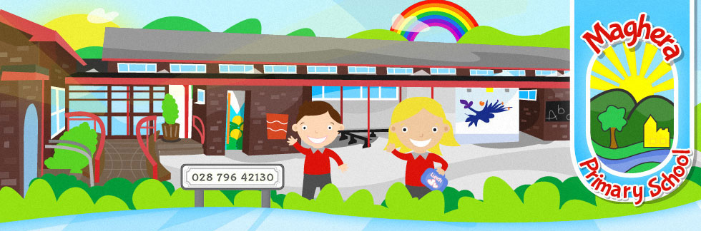

Mobile Phone Policy

Date Reviewed: March 2023

ACCEPTABLE USE OF MOBILE PHONES BY PUPILS

RATIONALE

At Maghera Primary School, we understand and accept that some parents/guardians give their children mobile phones to protect them from everyday risks involving personal security and safety. It is acknowledged that providing a child with a mobile phone gives parents reassurance that they can contact their child if they need to speak to them urgently.

Maghera Primary School therefore has established the following ‘Acceptable Use of Mobile Phones by Pupils Policy.’ The policy provides teachers, pupils, parents/guardians with guidelines and instructions for their appropriate use during school hours.

This policy also applies to students during school visits, trips and extra-curricular activities.

Maghera Primary School strongly discourages pupils from bringing mobile phones to school. The school takes no responsibility for mobile phones. Mobile phones are brought to school entirely at the owner's risk. The school accepts no responsibility for replacing lost, stolen or damaged mobile phones.

If pupils bring mobile phones to school, the phones must remain switched off and kept in their school bag while pupils are in class, the school building, the school grounds or during off site activities.

Should parents need to contact pupils during the school day, or vice versa, this should be done via the school office.

Where a pupil is found by a member of staff to be using a mobile phone during the school day, the phone will be taken from the pupil and stored in the office. The child’s parent/guardian will be contacted to collect the phone from the office.

Phones must NEVER be used to photograph other children or staff within the school. There may be children in school whose parents have opted for 'no photographs' in the consent forms.

If a pupil uses a mobile phone (e.g. Phone calls on school premises, to send texts or to take photographs/video footage of either other pupils or teachers), this will be regarded as a serious offence and the Principal will decide on appropriate disciplinary action in line with the school’s Positive Behaviour Policy.

If a pupil repeatedly misuses their mobile phone on school premises they will be required to leave the phone at the school office during the school day. The pupil would collect the mobile phone before leaving the premises at the end of the school day.

It should be noted that it is a criminal offence to use a mobile phone to menace, harass or offend another person. The Principal or any member of staff may consider it appropriate to refer any such matter to the PSNI.

If images (photographic or video) of other pupils or teachers have been taken, the phone will not be returned to the pupil until the pupil, in the presence of the Principal and the child’s parent/guardian has removed the images.

In exceptional circumstances a mobile phone may be retained until further advice has been sought.

The Principal will contact parents/guardians in all cases where inappropriate photographs/video/audio footage has been found and the PSNI may also be contacted.

RELATED TECHNOLOGY

The procedures applying to the inappropriate use of mobile phones, apply equally to the inappropriate use of related technologies with similar capabilities, eg, messaging, recording (audio & video), photography etc.

EXEMPTIONS

Exemptions of this policy can only be approved by the Principal and then only in exceptional circumstances.

CONCLUSION

Maghera Primary School does not allow the use of mobile phones by children in school or on school trips.

It is essential to be aware of safety issues regarding mobile phones which now increasingly have internet access. Staff use of mobile phones, only when necessary, should be discreet. Mobile phones should not be used in the classroom setting and should not be visible to pupils throughout school.

