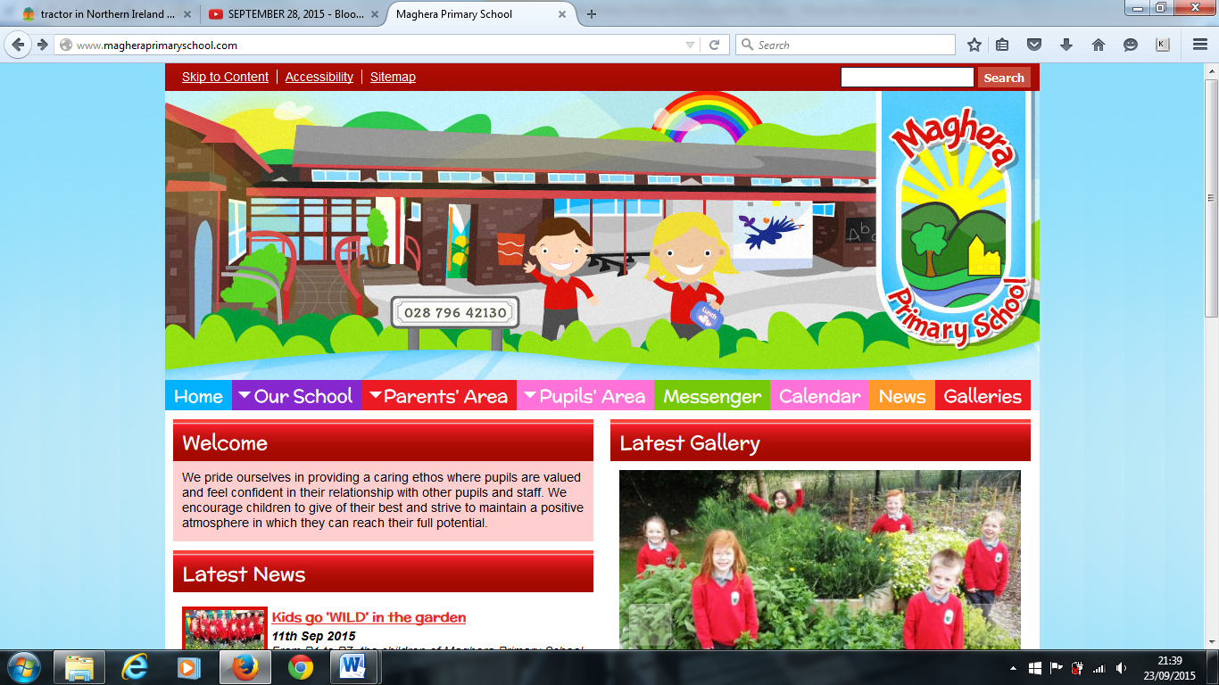

Welcome to our October Newsletter. Here you will find lots of information about things that will be taking place coming up to Half Term break.

**Safeguarding and Child Protection**

Designated Teacher: Mrs. L Brown

Deputy Designated Teacher: Mrs. L Mawhinney

Designated Governor for Child Protection: Dr K Dripps

Chairman of the Board of Governors: Mr. T McCracken

**School Uniform –** School uniform is important and gives our pupils a sense of belonging.

We would encourage the wearing of full school uniform everyday including black school shoes.

Please make sure all items of uniform are clearly labelled.

**Parent /Teacher Interviews**

Parent / Teacher interviews will take place from Monday 23rd to Wednesday 25th October. School will close for all pupils at 1:15 pm to facilitate the interviews. There will be no PAL Club or Homework Club on these dates.

**Samaritan’s Purse Shoebox appeal**

We are pleased to support the Samaritan’s Purse “Operation Christmas Child” again this year. Shoeboxes must be returned by Monday 23rd October. The donation for each box is £5. For gift suggestions and more, visit:

[WWW.SAMARITANS-PURSE.ORG.UK/OCC](http://WWW.SAMARITANS-PURSE.ORG.UK/OCC)

**Harvest Assembly**

Pupils are busy preparing for our Harvest Assembly on Thursday 26h October. Our Assembly will start at 10 am. Parents are welcome to attend from 9:30 am. We look forward to seeing you there.

As part of our learning about Autumn we are asking for families to kindly donate non - perishable items to give to the foodbank. Items should be brought into school from Monday 23rd October and left in the Assembly Hall.

**Sponsored Walk and Harvest Hooley**

Friday 27th October will see our Annual Sponsored Walk and Harvest Hooley. There will be a special Halloween lunch and all pupils will go home at 1:15pm.

**Anti-Bullying Week 2023**

To kick start Anti-Bullying week 2023 we are asking children to wear odd socks to school on Monday 13th November. Each teacher will complete activities in class to help us to learn how to be a good friend and be kind to each other.

Our Anti-Bullying Policy is available to view on the school website.

**Eco and School Council 2023-24**

Pupil elections will take place on Thursday 12th Octobe**r.**

**Healthy Eating**

We have been promoting and encouraging a healthy eating policy at school for a number of years and have made some progress with this. Our aim this year is to build on this progress and continue to raise awareness. Research has shown that a healthy snack at break time can help with pupil’s concentration and behaviour in the classroom. Please read our Healthy Breaks Policy on the school website.

**Contact with Staff**

There are times in school life when parents need to talk to a member of staff about a serious concern. When this occurs please make an appointment with Amanda for before or after school. Staff cannot leave class when they are teaching or supervising children in the morning or afternoon.

We appreciate your cooperation in this matter.

Maghera Primary School 6h October 2023 – www.magheraprimaryschool.com

**Maghera Primary School 25th Sept 2020 www.magheraprimaryschool.com**

**Oct 30**

**Fall Festival**

#### Jan 1

**New Year**

**Feb 2**

**No School**

**Dec 1**

**PTA**

***DIARY DATES***

* Friday 20th October Whole School Flu vaccinations
* Monday 23rd - Wednesday 25th October Parent / Teacher Interviews
* Wednesday 25th October Amazing Journey by Baptist Youth
* Thursday 26th October Harvest Assembly @10 am
* Friday 27th October Sponsored Walk and Harvest Hooley
* Thursday 7th December Jack and the Beanstalk at The Millennium Forum

***Advance Notice – Change of date!***

Saturday 9th December - Open Morning/Breakfast with Santa