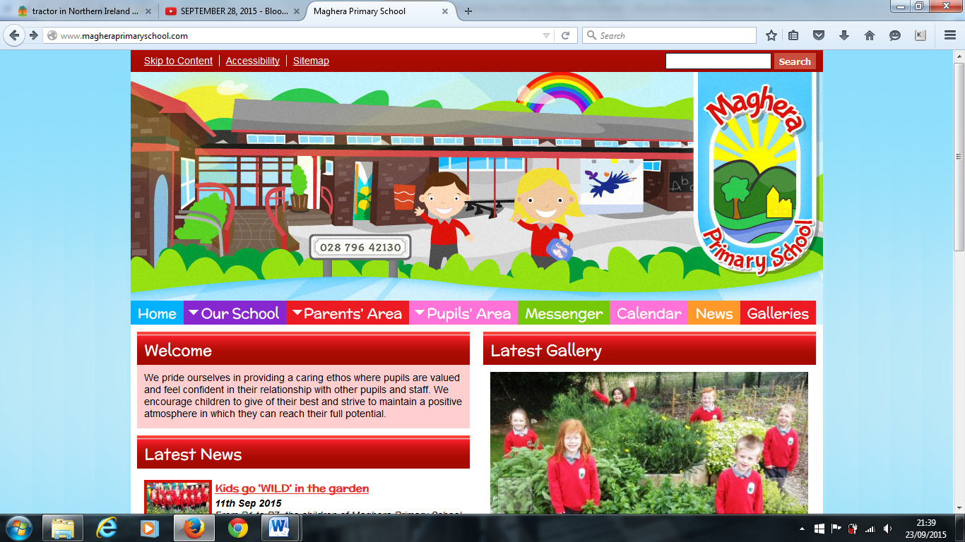

**P7 Transfer Test**

We would like to wish our P7 pupils doing their first SEAG test on Saturday 11th November 2023 every success. Remember: Read the Question!

**Strike Action**

Please note that non-teaching staff have the option of taking strike action on Thursday 16th November 2023. Please note there will be **no school dinners** on that day, **ALL PUPILS** must bring their own packed lunch and break, including those in receipt of free school meals.

**Reminder – Christmas Pantomime**

Please forward any outstanding payment with permission slip for the Pantomime to the School office as soon as possible.

**Christmas Performances**

This year there will be a whole school Christmas Performance on Wednesday 13th December and Thursday 14th December from 10am-11.15am. Further details will follow including information about ticket sales.

**Important Notice**

Mrs Mawhinney will be out of school for an unspecified period, due to personal circumstances. During her absence, Mrs L Brown, Senior Teacher, will answer any queries.

**Breakfast with Santa/School Open Morning on Saturday 9th December, 9.30 – 11 am.**

This year we have decided to have a Saturday morning event, Breakfast with Santa. This will run alongside an Open Morning for prospective new parents joining the school in September 2024. Please try to keep this date free as we love to see as many people as possible.

Welcome to our November/December Newsletter. Here you will find information about what will be happening in school from now until the end of term. Please keep visiting our school website for all our latest news and to check our school calendar for dates.

**Breakfast Club** – Breakfast Club is running from 8:10 am – 8:40 am each day at a cost of £1:05 a day with 50p admission per child per day.

**Foodbank Appeal**

Heather Boyd from Maghera Cross Community Link wishes to pass on her sincere thanks for the outstanding response by you to this appeal. Lives will be made better by your generosity.

**Sponsored Walk**

Thanks too for the marvellous support for our sponsored walk. An amazing £1170.20 was raised.

**Operation Christmas Child Shoebox Appeal**

Mrs Beth McIlrath collected the shoeboxes. Warmest thanks to everyone who filled a shoebox. These will be going to needy children who will really appreciate their gift.

**Poppy Appeal**

Thanks once again to those who kindly donated to the annual Poppy Appeal. The children loved the items on sale.

**November 13-17th is Anti Bullying Week.**

Pupils are asked to wear Odd Socks together with their full school uniform on Monday 13th November 2023 (no payment required). Each class will participate in various activities on this theme throughout the week.

Maghera Primary School November 2023 – www.magheraprimaryschool.com

**Maghera Primary School 25th Sept 2020 www.magheraprimaryschool.com**

**Oct 30**

**Fall Festival**

#### Jan 1

**New Year**

**Feb 2**

**No School**

**Dec 1**

**PTA**

***DIARY DATES***

**13th November Odd Socks Day 2023 (no charge)**

**13-17th November Anti-Bullying Week**

**16th November Non-Teaching Staff Strike Action**

**20th November PSNI Road Safety Talk for the Whole School**

**30th November Magherafelt High School P7 Taster Day, 10am-2pm. Parents to leave and pick up**

**Advance Notice:**

**6th December Christmas Dinner in School**

**7th December Christmas Pantomime at The Millennium Forum, leaving at 9am sharp**

**9th December Breakfast with Santa and Open Morning**

**13th & 14th Dec Whole School Performances**

**20th December School Closes at 12 noon with pupils returning to school on 4 January 2024**