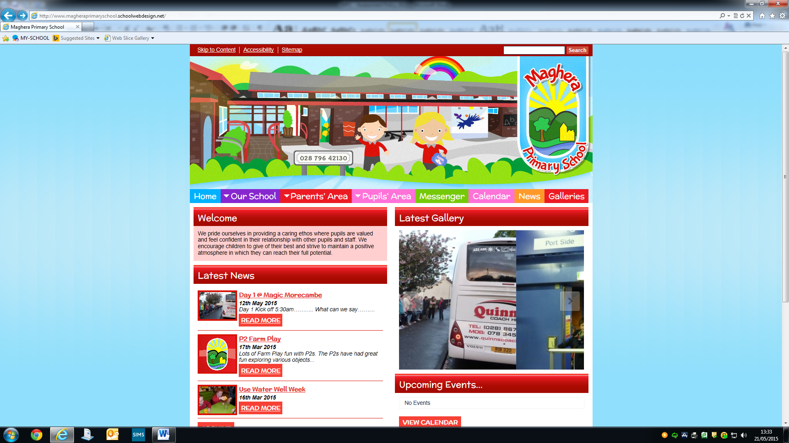

MAGHERA PRIMARY SCHOOL
15 Station Road, Maghera, Co Londonderry, BT46 5BS

E-mail: info@magheraps.maghera.ni.sch.uk
Website:www.magheraprimaryschool.com

Tel: 028 796 42130

8th June 2020
Dear Primary 7 and Parents,
We hope you are all keeping well and taking care of yourselves. We know that this is not the end of your primary school experience that you all expected but as I promised at the start of this, we will have a day together when we can celebrate all your wonderful achievements during your time at Maghera Primary School.

To help us get the process started, we would like to offer you the opportunity to purchase a Leavers’ Hoodie.
If you are interested could you please email the info@magheraps.maghera.ni.sch.uk account before Thursday 12th June, so that I can indicate numbers to the supplier.

If you are interested, please follow the instructions below:
- Indicate what size you need on the form below. The sizes are 9-10, 10-11, or 13.
- Return the order form and payment to school on Thursday or Friday between 12pm and 2pm.
- Exact money only please as we want to ensure social distancing.
- The hoodie will have “Class of 20” on the back with the Maghera Primary School crest on the front. The names of all the Primary 7 children will be included.
- The cost of the hoodie will be £22.

Many thanks,
L Mawhinney
Principal

--------------------------------------------------------------------------------
Order Form for Leavers’ Hoodie

Name of Pupil: ________________________ ________________

Size : ______________

Parent signature _______________________

