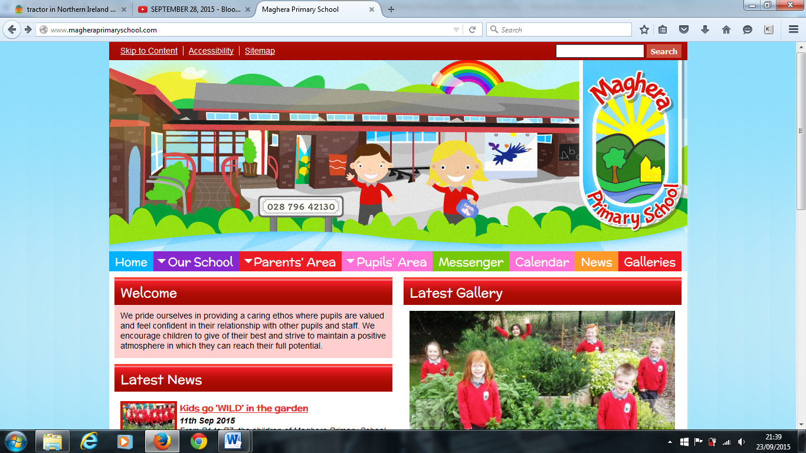

**Anti-Bullying week begins on 16th November and to mark this we have decided to hold an ‘Odd Sock Day’ on Friday 20th. Children are encouraged to come to school wearing odd socks on Friday as a fun event with no cost incurred.**

**Contacting staff** – Should any parent need to speak to a staff member, please telephone the School office to make an appointment to do so outside teaching time – before 8.45 am and after 2.50pm. This will avoid disruption of class teaching time.

**P1/P2 Class** - Mrs Mawhinney will be teaching P1/P2 Wednesday to Friday from now until Christmas. Mrs Davis will be teaching Monday and Tuesday. Should you require to speak to Mrs Mawhinney, please make an appointment on her non-teaching days – Monday or Tuesday.

**Covid-19**

As cases of Covid-19 continue to rise, please remember that although we have been abiding by all the guidelines, we need to continue to be vigilant.

* All staff and children follow good sanitising and handwashing throughout the day.
* School bags go home on a Monday and homework is returned during the week on the Seesaw app. School bags are returned on a Thursday.
* Media reports recommend that parents wear a facemask when dropping off and picking up their children.
* We have kept the classes in their smaller ‘bubbles’.
* Class Bubbles do not mix at break or dinner time or during the school day.

**Operation Christmas Child** – Please support this worthy cause in bringing joy to less fortunate children at Christmastime. Filled shoeboxes should be sent to School as soon as possible, or if you prefer, online donations can be made direct to Operation Christmas Child via their website.

Welcome back, I hope you enjoyed the extended half-term break. Now we are back to school we are looking forward to the Christmas activities. We will not be able to have some of our usual events but hopefully we will be able to have a short virtual show for each class that you can enjoy.

Thank you for 2 donations received from a former member of our school community. Their donation was very kind and thoughtful. Thank you also to Maghera Community Association for their very kind donation.

School start and finishing times will remain the same for this term. Please practice social distancing at the school gate. Parents and grandparents have diligently followed drop off and pick up times. Thank you for your cooperation.

**Poppy Appeal** – Thank you for supporting the Royal British Legion Poppy Appeal in School. We will let you know the amount raised in the next edition of the Messenger.

**Year 1 Pre-Enrolment Information** - If your child was born between 2nd July 2016 and 1st July 2017, they will be due to start school in September 2021. If you would be interested in hearing about Maghera Primary School and what we have to offer you and your child, please contact Mrs Mawhinney via the School office.

**Christmas Raffle** - The PTA will continue with a Christmas raffle and would appreciate any donations towards our prizes, so far to date we have:

Yankee Candle gift set – McCloys

Placemat/coaster set – Donaghys

£20 voucher – Gibson Hair Salon

Tropic Skincare goodies – Emma O’Hagan

Meal voucher – Walsh’s Hotel

Voucher – Pizzeria, Maghera

Water bouquet – Nelson’s Flowers

**Absent notes** – an online form is preferable to a hand-written note. The EA are monitoring absence codes, so please return your note promptly on return to school to enable the correct code to be inputted for EA analysis.

**Maghera Primary School November 2020 www.magheraprimaryschool.com**

**The Messenger**

**Oct 30**

**Fall Festival**

#### Jan 1

**New Year**

**Feb 2**

**No School**

**Dec 1**

**PTA**

***DIARY DATES***

**20th November ‘Odd Sock Day’ (no cost)**

**10th December Christmas Jumper Day – charity donation of £1**

**10th December Christmas Buffet Dinner**

**17th December Last day of paid School milk**

**18th December School closes for Christmas break at 11.30am**

***It’s as easy as 1, 2, 3, to raise money for school.***

***As we become increasingly reliant on online shopping and are approaching the Christmas season, please remember that you help fund-raise for the School through Easy Fundraising!*** *One of the simplest and free ways to raise money for our School is through www.easyfundraising.org.uk and follow the instructions or DOWNLOAD THE APP. Every time you make on online purchase, use the app or easyfundraising website, selecting Maghera Primary School for donations. There are numerous outlets including Tesco, M& S, Argos, Amazon etc. No catches or costs! School gets all the donations.*

**Reminder – School Uniform**

We are delighted to see the efforts parents have gone to in sending the children to School in accordance with the standards of our School Uniform Policy. The children’s appearance is very smart and tidy.

Tracksuit bottoms or leggings do not form part of our uniform and should not therefore be worn to School.

**Crossing Patrol** – Due to the congested nature of parking around the School on a busy road, please keep the area at the School gate free from vehicles. This will ensure the safety of our Crossing Patrolman, Mr Early, and the children he is escorting across the road, giving a clear line of vision to motorists.

**Homework** – Although homeworks are now slightly different considering Covid requirements, they still form an integral part in your child’s education. As such homework should continue to be completed, with a photograph of completed work submitted to our Seesaw platform. Please also ensure that all reading books are returned to School promptly.

As you are aware, our School is using online learning platforms such as Education City and Seesaw to progress your children’s learning while adhering to the restrictions we are currently facing. Thank you for your continued support in accessing these online tools. Should you require support or guidance please contact the School.

**Reminder – Free School Meals Entitlement**

If you feel that you qualify for Free School Meals Entitlement or a Uniform Allowance, please contact the School office or visit –

<https://www.eani.org.uk/financial-help/free-schools-meals-school-uniform-allowance>

As Winter approaches the days are now getting colder and wetter. The children are going outside in these weather conditions, so they **must** bring a **warm waterproof coat with a hood**, gloves, scarves, and hat. These items are an essential part of your child’s uniform and should be brought to School every day.

**Parent/Teacher Interviews** - Parent/Teacher interviews had to be cancelled this term. Primary 1 and Primary 7 were scheduled to take place over the telephone during week beginning 16th October. These have been rescheduled. Parents of pupils in P2 – P6 will receive a short-written report during the week beginning 16th November.

**Christmas Jumper Day** will be held in School on Thursday 10th December with a donation of £1 made to charity. Time once again to get those reindeers, Santa and snowmen out of the wardrobe!

**Friendly reminder -** Children should not bring bags to and from School except for disposable lunch bags. We allow drinks bottles which can be washed and sanitized each evening.

***Remember – Check out our Website for more photos!***