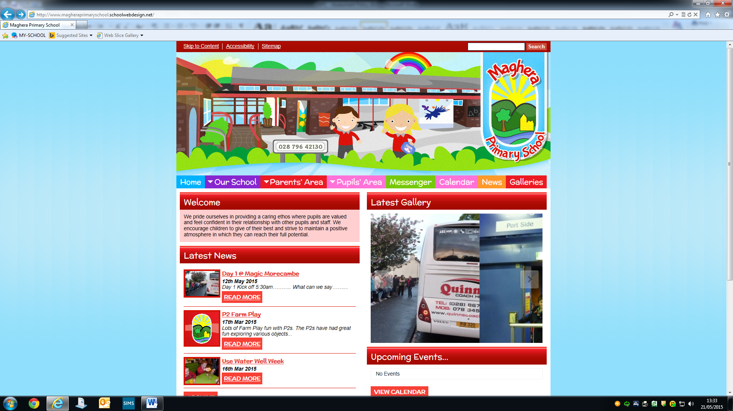

MAGHERA PRIMARY SCHOOL
15 Station Road, Maghera, Co Londonderry, BT46 5BS

E-mail: info@magheraps.maghera.ni.sch.uk
Website:www.magheraprimaryschool.com

Principal: Mrs L Mawhinney Tel: 028 796 42130

1st March 2021

Dear Parent/Guardian

I hope you and your families are all keeping well. I am sure you are aware of the announcement made by the NI Executive about plans for a phased return of pupils to school in March. The Education Minister has written to schools to inform us that P1 to P3 pupils will return to face to face teaching on Monday 8th March 2021 for 2 weeks until Friday 19th March 2021 (excluding St Patricks Day on Wednesday 17th March when school will be closed). They will return to remote learning for the last week of term Monday 22nd to Friday 26th March 2021.

We have been very busy drawing up a safe plan to enable this to happen. However, we are waiting for a confirmed date for the return of P4-P7 pupils. Once we are informed we will be in touch with you all.

In the mean-time school will continue to provide supervision for vulnerable children and the children of keyworkers until such times as a full return to school is instructed by the minister.

Supervised Learning
It is very important that parents whose children are attending school interact with Seesaw by checking in daily to see what work has been set, to upload any work completed and for feedback and messages from their teachers.

Many thanks for your continued support.

Mrs L Mawhinney
PRINCIPAL

