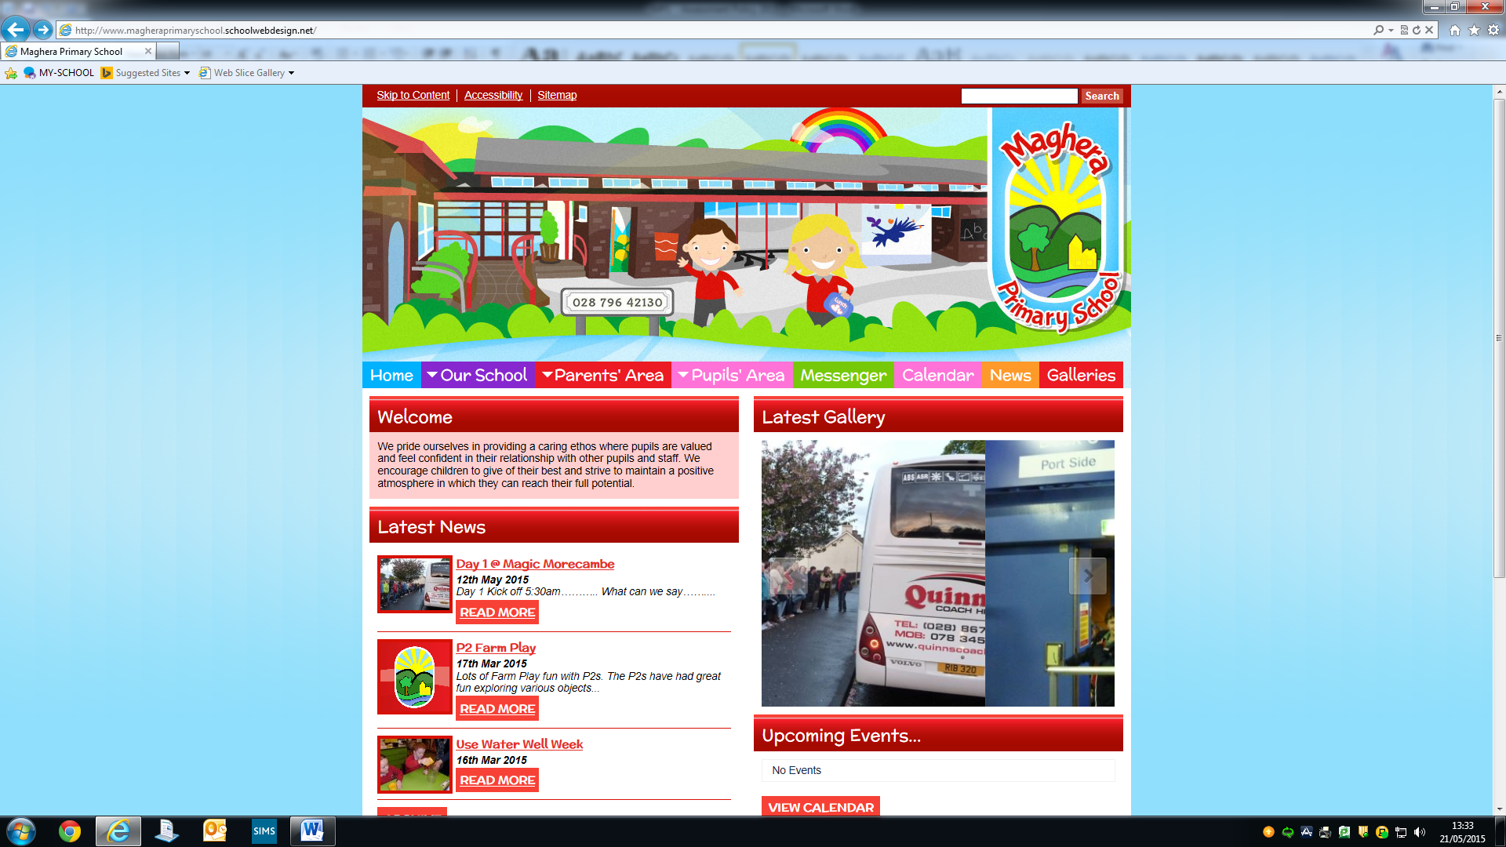

MAGHERA PRIMARY SCHOOL
15 Station Road, Maghera, Co Londonderry, BT46 5BS

E-mail: info@magheraps.maghera.ni.sch.uk
Website:www.magheraprimaryschool.com

Principal: Mrs L Mawhinney Tel: 028 796 42130

2nd March 2021

Dear Parent/Guardian,

P1-P3 return to school for pupils

We are delighted that our Primary 1-3 children are back to school on Monday 8th March 2021 for 2 weeks (excluding St Patricks Day Wednesday 17th March). We wish all the classes were back, but we hope to see P4-P7 after Easter. We will communicate with parents regarding this as soon as we have confirmation from the Department of Education.

Pandemic

Please do not send your child to school if they or anyone in our household have any of the following symptoms: -

- A high temperature
- A new continuous cough
- A loss of or change in sense of smell or taste

Drop off and Collection Reminder

There is a change to drop off and collection times from Term 1 due to the reduced numbers of classes on site.

Primary 1 and 2 Start time 8.50 am End time 1.50pm
Primary 3 Start time 8.55 am End time 1.55pm

****Please note Primary 3 will be in the P3/4 classroom in the Main School Building ****

Children should line up at their classroom door promptly at the allocated time.
Parents SHOULD NOT enter the playground and should wear a mask and maintain social distancing rules AT ALL TIMES. Classroom assistants will be in the playground to supervise the children as they walk to the school building and line up at their doors.
Teaching staff will collect their class at the designated time from the outside classroom door. Any child who is late should proceed to their classroom door and wait to be collected. Social distancing of 2 metres will remain in place between adults and as far as possible between adults and pupils. Each class will continue to act as a “protective bubble”. There will be no mixing of class bubbles at break or lunchtimes.

Break and Lunchtime Arrangements

There will toast available at break time and children in Primary 1-3 can order school dinner. Pupils can bring break and lunch in either a disposable bag or a lunchbox. If you are sending a lunchbox we would encourage parents to wipe down lunchboxes and water bottles on return from school each day.

Curriculum
We want to support our pupils to feel happy and safe on their return to school. We wish to reassure pupils and their parents that we will provide opportunities to support Health and Well-Being through practical, challenging play-based learning in a stimulating environment. We will encourage and support the pupils to reconnect socially with their peers in their class bubble. For these few weeks our learning will be practical as much as possible through Play, Physical Education, Outdoor Learning and The Arts as advised by the Department of Education.

Hygiene
All hygiene measures adopted in Term 1 will continue to be implemented.
Handwashing, will be encouraged throughout the day. Hand Sanitiser is available on entry to the classrooms. Parents may wish for their child/children to have individual hand sanitiser and may send this into school clearly labelled with their child’s name on it.

Pupils should wear clean uniform everyday.

**** Please note this is a change from previously – wearing school uniform includes vulnerable children and the children of key workers from Monday 8th March ****

A selection of preloved uniforms will be in the reception of school on Thursday 4th and Friday 5th March 2021. A voluntary contribution to School Funds would be greatly appreciated. If you have any queries, please feel free to ring the school office to speak to a member of staff.

Yours sincerely,

Mrs L Mawhinney
Principal

