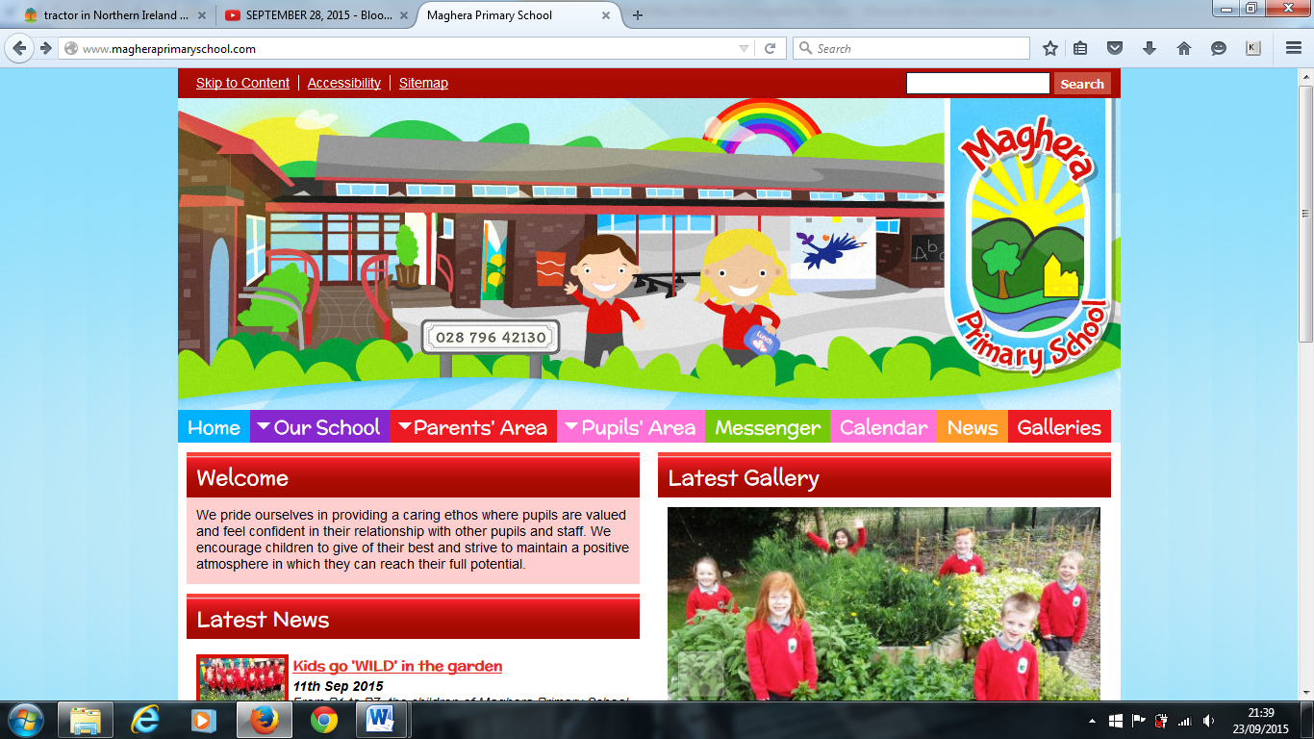

**PARENT MEETINGS** – These will take place throughout October by telephone in order to protect staff and parents. Times and dates will be issued by teachers soon. Books will be sent home on 13th October for you to look at, sign and return to school no later than Friday 15th October.

**PARENT/TEACHER CONTACT** - If you should have any pressing concerns or wish to speak to your child’s teacher, please contact the school office to make an appointment after 3 pm.

**ABSENCE NOTES** – should your child be absent from class please complete an absence note and return immediately. Absenteeism is recorded and monitored daily. A copy of our Attendance Policy can be found on our website accompanied by Absence Notes for your completion.

**Covid-19 REMINDER** - should your child exhibit any Covid-19 symptoms, dry cough, temperature, loss of taste and smell, or feel generally unwell, do NOT send your child to school.

PHA are now completing all Track and Trace in schools. You will therefore not be contacted by the school and asked to isolate and test. If this is necessary, you will instead be contacted by the PHA. A ‘warn and inform’ letter from the school will notify you if a positive case has arisen.

**Parental help request** – **Saturday 16th October 10am.** If you are available for a clean-up in the school garden to cover weeding, power hosing, and general maintenance we would be more than happy to welcome you!

**Free School Meals and Uniform Grants**

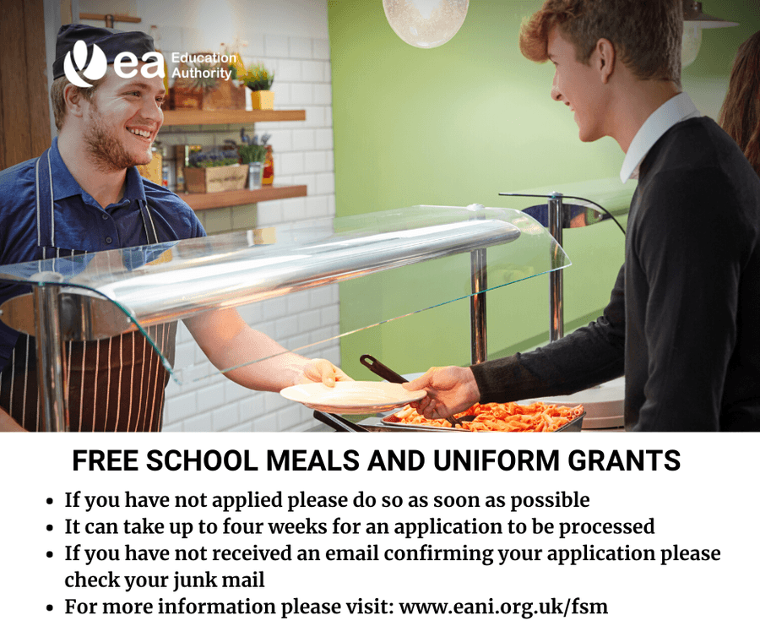

<http://www.eani.org.uk/fsm>

Parents please check if you are entitled and have made your application for Free School Meals and the Uniform Grant – check the link above.

**PARENT SUPPORT GROUP MEETING** – This will be held on Wednesday 6th October at 3pm. This is open to new and not so new parents who are willing to get involved in supporting the school. We would be delighted to have you join our group.

**Welcome to The Maghera Messenger which we hope will help you keep up to date with events around the school.**

**PAL CLUB** – PAL Club is for children who are in P1, P2 or P3 and runs daily between 1.50 pm and 2.50pm at a cost of £2 per day commencing on Monday 4th October 2021.

There is an interesting variety of activities provided for the children.

Children who attend the club will develop new skills, as well as building friendships and have lots of fun!

Parents of children who are attending the club should sign up and pay for the club weekly or complete the note giving notice of dates required. This enables the school to keep a track of attendance and employ additional staff to run the club. Please advise the school if you wish to avail of this service.

**SMOKING** - in line with the EA guidelines smoking is discouraged at the school gate.

**SAFEGUARDING** – please remember if you have any concerns involving the welfare of children either inside or outside of school. Please share these concerns with either Mrs Brown the Designated Teacher for Child Protection or Mrs Mawhinney Principal.

**HEALTHY BREAKS POLICY** – in accordance with school policy we would ask you to send water, not juice to school. Water dispensers are freely available around the school should refills be required. Our Healthy Break Policy is available on the school website.

**COATS** – as the weather is changing please ensure your child attends school with a warm waterproof coat every day. Please also adhere to the school uniform policy and provide your child with the **proper footwear and grey school trousers, tights or skirt. Please label all items of clothing with your child’s name.**

**SHOEBOX APPEAL** – if you wish to take part in this Charity appeal please forward your filled shoebox to school before Friday, 22nd October. Thank you for your participation. <https://www.samaritans-purse.org.uk/what-we-do/operation-christmas-child/how-to-pack-a-shoebox/>

**HALLOWEEN** – On Tuesday 26th October children can either dress up, or attend school in their normal clothes if they do not wish to dress up. School closes at normal time on this date, and is closed from the 27th October, returning on Tuesday 2nd November.

**Maghera Primary School October 2021 www.magheraprimaryschool.com**

**The Messenger**

**Oct 30**

**Fall Festival**

#### Jan 1

**New Year**

**Feb 2**

**No School**

**Dec 1**

**PTA**

***DIARY DATES***

4th October P3 will be staying until 2.50 Monday and Tuesday from now on

6th October 3 pm Parent Support Group Meeting

16th October School Clean Up. Please come along to do some either late/early spring cleaning around the school

22nd October Pleas return the pantomime notes and money by 22nd October

22nd October Operation Christmas Child - last day for the collection of shoeboxes

22nd October PSNI visit to educate the children on Road and Fireworks safety

26th October Last day before the holiday, children can wear either their own clothes or dress up

27th October School closes, reopening 2nd November

**Flu vaccine – no date as yet, we will keep you informed !**

***Remember – Check out our Website for more photos!***