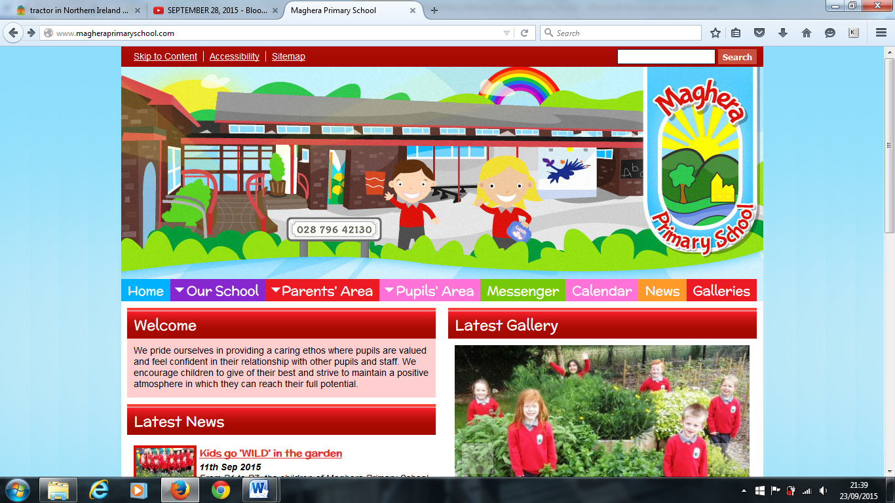

Maghera Primary School 25th February 2022– www.magheraprimaryschool.com

**After Schools club**

Teacher led after school clubs will commence week beginning 28th February.

Tuesday 3 - 4 pm - P3 /4 Coding / ICT

P5,6,7 Coding / ICT

P5,6,7 Book Club

P6 EMC

Wednesday 3 - 4 pm P 5,6,7 Choir / Music Club

*Football will recommence on Friday 11 March with Stewart Lennox – information will follow.*

As the year progresses we have been taking various classes to the Greenvale Leisure Centre for swimming lessons. We are delighted with the children’s progress and would encourage you to build on their progression and development. For those children yet to start swimming lessons we would encourage you to introduce your child to the pool and get them used to changing themselves and familiarise them with the swimming pool.

As we begin return to the normal school routine, classes have now resumed to Maghera Library as in pre Covid times. Please remember to return the book loaned promptly and in good order.

**World Book Day –**

World Book Day occurs next Thursday 3 March. Pupils will engage in literacy activities during the school day. This will be a non-uniform day and pupils can dress up as their favourite character if they wish – there is no obligation to do so.

Now that we are trying to resume some sort of normality in everyday life regarding Covid 19 restrictions, we would be grateful if your child could resume wearing full school uniform each day of the week including black school shoes. This includes P7s going swimming on a Friday. We appreciate your co-operation in this matter.

Welcome to our February/ March Newsletter. Here you will find lots of information about things that will be happening this half term. We would encourage you to keep up to date with school information via our school website.

**Breakfast Club** – Breakfast Club is running from 8:10 am – 8:40 am each day at a cost of £1:05 a day.

**Healthy Breaks Policy** – As a school we believe strongly in the benefits of our children having a healthy break. A healthy break can help pupils sustain good concentration and behaviour for longer periods in the classroom. Please see our Healthy Breaks Policy on the school website.

**Safeguarding and Child Protection –** The school’s Safeguarding Policy is on the school website.

Mrs. L Brown is our Designated Teacher for Child Protection and Safeguarding and Mrs. L Mawhinney is our Deputy Designated Teacher for Child Protection and Safeguarding. Please remember that if you have any concerns about your own or another child outside school, you should share these concerns with Mrs. Brown. Mrs. Mawhinney or Dr K Dripps (Designated Governor for Child Protection and Safeguarding).

**Absence Notes –**

If your child is absent from school for any reason, please complete the Absence Explanation Note found on the school website under the Parents tab. A copy can also be obtained from your child’s class teacher.

**Parent /Teacher Interviews –**

Parents meetings for any parent who wishes to speak to the class teacher for P3-7 will now take place in March and will be held via telephone as before. Further information will be issued soon.

**Maghera Primary School 25th Sept 2020 www.magheraprimaryschool.com**

**Oct 30**

**Fall Festival**

#### Jan 1

**New Year**

**Feb 2**

**No School**

**Dec 1**

**PTA**

***DIARY DATES***

**1 March Shrove Tuesday**

**3 March World Book Day - see above**

**17 March School Closed – St Patrick’s Day**

**8 April Last day of swimming for P7 pupils**

**11 April School closed for Easter Holidays**

**25 April School reopens**

***Remember – Check out our Website for more photos!***