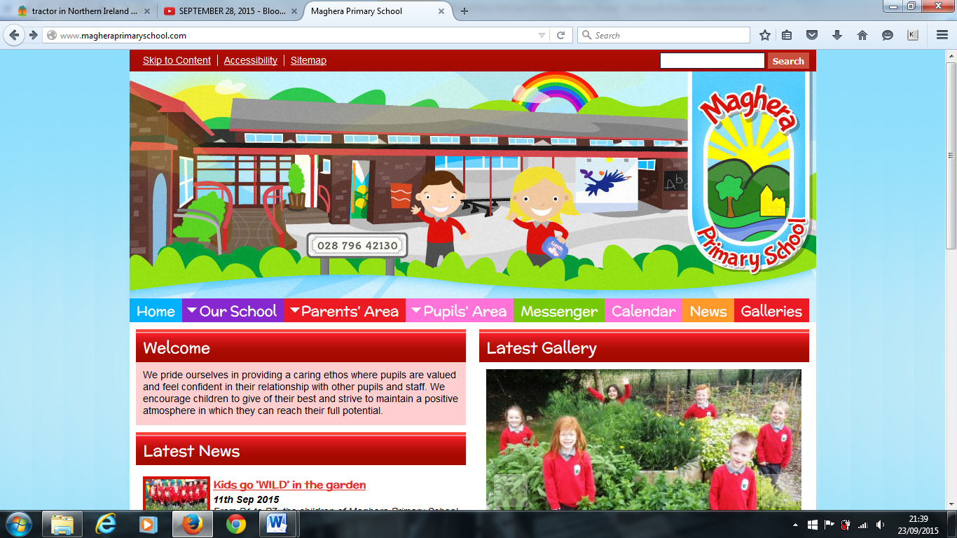

We wish to extend a warm welcome to our new parents, and welcome back for our existing school community. It was great to see all our pupils return to school on Tuesday 30th August. We would encourage you to keep up to date with school information via our School website. If you have any questions email the school email address at [info@magheraps.maghera.ni.sch.uk](mailto:info@magheraps.maghera.ni.sch.uk) or phone the school office.

**Start and Finishing times –**

School starts at 8:50 am for all pupils. There is supervision in the front playground from 8:40am. Children can arrive at any time during this period. Children will be collected at the door of their classroom by class teachers. After this time all pupils should enter school via the main entrance.

School finishes for Primary 1 pupils at 12:00 pm until 16th September. From 19th until 30th September Primary 1 pupils will go home after lunch at 1pm.

**P1 full school day** - P1 pupils will remain in school as from 2nd October until the normal finish time of 1.50pm.

**Breakfast Club** – If you wish to avail of this service please contact the school office in order to ascertain numbers, charge will be £1.05 per day.

**PAL Club -**  Play and Learn club will commence on Monday 12th September for all pupils from 2pm until 4:30pm. Please see separate note on the school website.

**Safeguarding and Child Protection**

A copy of our updated Safeguarding and Child Protection Policy is on the school website under Our School – Policies.

**Please take time to read this policy carefully.**

Your child will receive a slip for you to fill in stating that you have read it and are aware of the guidelines which our school, uses in dealing with matters of a child protection nature and the names of those individuals with special responsibility for Child Protection in school.

**Milk money**

Milk orders and money must be received by Monday 5th September. The total payment for Term one is £13.20.

There will be no refunds for absent days. Milk will be available form Monday 12th September until Tuesday 20th December.

Additions cannot be added after the above date.

**Dinner money and menu**

Dinners continue to cost £2.60. Please ensure that dinners are paid at the beginning of the week. The dinner menu can be found on the school website. We would encourage anyone who has not yet completed their Free School Meals Application form to complete this as soon as possible thus ensuring your child receives their FSM entitlement.

**Attendance**

**Please read the Attendance policy on the school website.**

If your child is absent from school, please contact the school office. An absence explanation note **must** be sent in with your child on the day they return to school. This can be downloaded from the school website or one will be provided by your child’s teacher.

**Data Collection and Permission Slips**

Please ensure that all permission slips and data collection forms are returned to school ASAP.

Maghera Primary School 2nd September 2022– www.magheraprimaryschool.com

**Maghera Primary School 25th Sept 2020 www.magheraprimaryschool.com**

**Oct 30**

**Fall Festival**

#### Jan 1

**New Year**

**Feb 2**

**No School**

**Dec 1**

**PTA**

***DIARY DATES***

**26th Sept School closed to pupils for teacher training**

**2nd Oct P1 pupils stay for full school day until 1.50pm**

**5th Oct School Photographs – Tempest Photography**

**24th -27th Oct Hope for Youth Ministries 2:15 – 3:00pm**

**14th Nov School flu vaccination – provisional date**