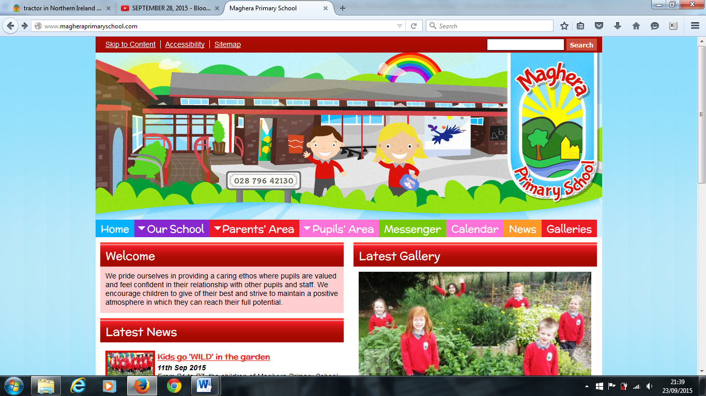

Welcome to our October Newsletter. Here you will find lots of information about things that will be taking place coming up to Half Term break.

Autumn has arrived and the weather has certainly turned colder. It is time to wrap up warm and send a labelled coat with your child every day as pupils go outside for outdoor play and learning.

**Safeguarding and Child Protection**

Designated Teacher: Mrs. L Brown

Deputy Designated Teacher: Mrs. L Mawhinney

Designated Governor for Child Protection: Dr K Dripps

Chairman of the Board of Governors: Mr. T McCracken

**School Uniform –** School uniform is important and gives our pupils a sense of belonging.

We would encourage the wearing of full school uniform everyday including black school shoes.

Please make sure all items of uniform are clearly labelled.

**Parent /Teacher Interviews**

Face to face Parent / Teacher interviews will take place from Wednesday 9th to Friday 11th November. School will close for all pupils at 1pm to facilitate the interviews. There will be no PAL Club on these dates.

**Harvest Assembly**

Pupils are busy preparing for our Harvest Assembly on Thursday 27th October. Our Assembly will start at 10 am. Parents are welcome to attend from 9:30 am. We look forward to seeing you there.

As part of our learning about Autumn we are asking for families to kindly donate non - perishable items to give to the foodbank. Items should be brought into school next week and left in the Assembly Hall.

**Parent Support Group**

Come and join us on **Tuesday 25th October at 7pm** for a meeting of our Parent Support Group.

Last year our Parent Support Group fundraising made enough money to pay for the buses to our summer school trips and we were able to purchase much needed reading books for our pupils. This year we would like to fundraise for new ICT equipment.

**Play and Learn Club**

Spaces are filling up quickly for our Play and Learn (PAL) club. This club runs after school every day from 2:00pm until 4:30pm.

There is help with homework and lots of exciting activities:

Cookery, Art and Crafts, Coding, Outdoor Play, Scavenger Hunts, Musical Instruments, Dance and Drama, Board Games, Movie Time, Sports, Lego, Gardening and much more.

Please give your booking form and the correct money to your child’s class teacher on a Friday morning to secure your place.

**School Payments**

Payments for dinners and toast must:

* be sent on a Monday
* be sent in a clearly marked envelope, stating what the money is for
* be the correct money

Payments MUST be made to the class teacher (not a member of staff on duty in the playground or at Breakfast Club). Many thanks for your co-operation in this matter.

**Confidentiality** – We encourage limited personal dialogue about your child at the school gate between teachers and parents to ensure the utmost confidentiality for your child. Should you have a concern, please make an appointment to speak to your child’s teacher by phoning the School Office.

**Contact with Staff**

There are times in school life when parents need to talk to a member of staff about a serious concern. When this occurs please make an appointment with Amanda for before or after school. We appreciate your cooperation in this matter

Maghera Primary School 18th October 2022– www.magheraprimaryschool.com

**Maghera Primary School 25th Sept 2020 www.magheraprimaryschool.com**

**Oct 30**

**Fall Festival**

#### Jan 1

**New Year**

**Feb 2**

**No School**

**Dec 1**

**PTA**

***DIARY DATES***

* Monday 24th to Thursday 27th October Youth for Christ Ministries
* Tuesday 25th October Parent Support Group meeting
* Wednesday 26th October Harvest Dinner
* Thursday 27th October Harvest Assembly
* Friday 28th October 2022 Sponsored Walk and party day
* Wednesday 9th November Amazing Journey by Baptist youth
* Monday 14th November Whole school Flu vaccinations

***Advance Notice***

* School may be required as a Polling Station. This will be an Exceptional Closure for all staff and pupils on

Friday 16th December 10 am – Provisional date for whole school Carol Service