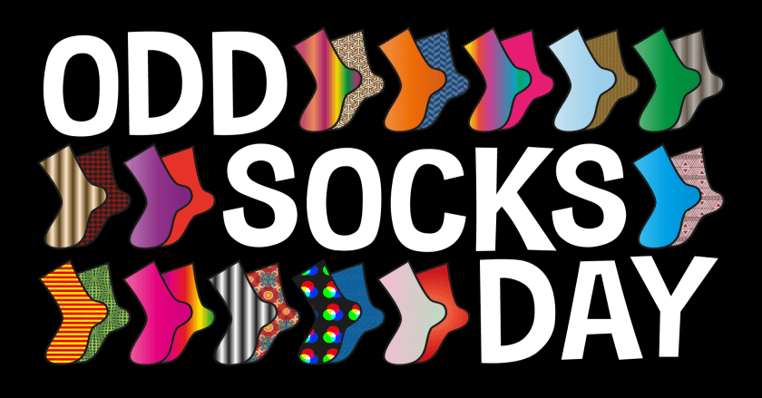

**ANTI BULLYING WEEK 14TH-18TH NOVEMBER** 2022

**FRIDAY 18TH NOVEMBER 2022**