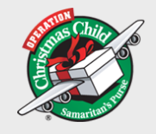 Shoe Box Appeal
9 Moyagoney Road
Kilrea
Co Londonderry
BT51 5SX
15th December 2022
Maghera Primary School

Dear Staff & Pupils

Many thanks for agreeing to run with the shoebox appeal again this year

The total boxes to leave Northern Ireland – 24,241 – which in the circumstances is a wonderful total.

Two containers have already left earlier in November and they have gone to Moldova and Bosnia and three more containers have now left two weeks ago and they are going to Romania, Poland and parts of Ukraine.

These boxes will all be distributed to children from Ukrainian refugee families and we hope and pray that this gift filled box will bring a little glimmer of hope and joy to each child who receives one

Please pass on my thanks to the children and parents for all their support.

Yours sincerely

Beth Mc Ilrath

