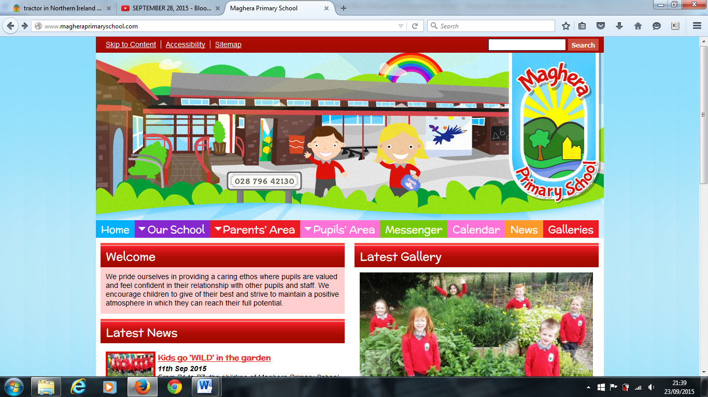

**Primary 1 Applications Dates for your Diary:**

13 December - Admissions criteria and information published on the EA website.

10 January 2023 - Online Application Portal opens at 12 noon.

27 January - Online Application Portal closes at 12 noon.

31 January - All supporting documents (Birth Certificates etc.) must be uploaded.

27 April – Notification of the outcome of your application.

**Healthy Eating** – Please encourage your child(ren) to eat healthily at break and lunch time. Breaks should be bread based, with fruit or vegetable snacks. Drinking water in class helps with concentration, therefore **only water** is permitted to drink during the day. Pupils should bring water (not fizzy or flavoured) to school in a CLEAR bottle. Please note that we are a **Nut Free School**.

**Confidentiality** – We encourage limited personal dialogue about your child at the school gate between teachers and parents to ensure the utmost confidentiality for your child. Should you have a concern, please make an appointment to speak to your child’s teacher by phoning the School Office.

**Christmas Dinner**

Thank you to Nan who cooked a delicious Christmas Dinner on Thursday 15 December. We would encourage you all to try our delicious school dinners in the New Year.



**Contact with Staff**

There are times in school life when parents need to talk to a member of staff about a serious concern. When this occurs, please make an appointment with Amanda for before or after school. We appreciate your cooperation in this matter

Welcome to our December Newsletter. Here you will find important information about what will be happening in Term Two.

**Safeguarding and Child Protection**

Designated Teacher: Mrs. L Brown

Deputy Designated Teacher: Mrs. L Mawhinney

Designated Governor for Child Protection: Dr K Dripps

Chairman of the Board of Governors: Mr. T McCracken

**School Closure**

School closes on Wednesday 21st December at 11:30 am. There will be no Breakfast Club or toast on this day.

We would like to wish you all a wonderful Christmas and best wishes for a happy and healthy 2023!

**Increase in Group A Streptococcus infections**

Due to the current outbreak of Scarlet Fever and Strep A, if your child gets unwell at school, we will contact you immediately. If you require any additional information on these infections, please visit the PHA website. If you are concerned about your child’s health, please contact your GP.

**Supper with Santa**

Many thanks to everyone who supported our Parent Support Group “Supper with Santa”. We raised a staggering £1600. This included takings at the door, the sale of raffle tickets and sales at the school stalls.

**Cancer Fund for Children**

Thank you to everyone who supported our Cancer Fund for Children Santa Claus Christmas Jumper Day and who donated to the retiring offering at our Carol Service. We have raised £213 for this worthwhile cause!

Maghera Primary School 20th December 2022– www.magheraprimaryschool.com

**Maghera Primary School 25th Sept 2020 www.magheraprimaryschool.com**

**Oct 30**

**Fall Festival**

#### Jan 1

**New Year**

**Feb 2**

**No School**

**Dec 1**

**PTA**

***DIARY DATES***

Wednesday 4 and Thursday 5 January - Magherafelt High School Open Nights.

Wednesday 18 and Thursday 19 January – Sperrin Integrated College Open Nights.

Thursday 19 January – Rainey Endowed Open Day.

Wednesday 25 January to Wednesday 1 February – Bookfair.

Saturday 4 February – Transfer Results.

Friday 10 February - P7 Transfer meetings.

Monday 13 to Friday 17 February - Half Term Break.

Thursday 2 March – World Book Day Celebration.

16 March - School Development Day.

17 March - School closed for St Patrick’s Day.