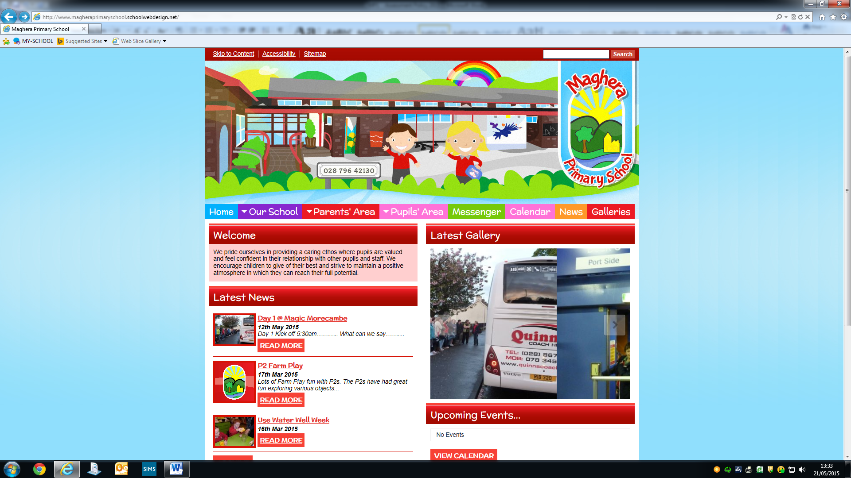

**Mrs Lesley Mawhinney**

**‘Principal & Deputy Designated Teacher for Child Protection’**

**Mrs Lorraine Brown**

**‘Designated Teacher for Child Protection’**

**Mr Thomas McCracken**

**‘Chair of Governors’**

**Our**

**Safeguarding**

**Team**

**Dr Kara Dripps**

**‘Safeguarding Governor’**

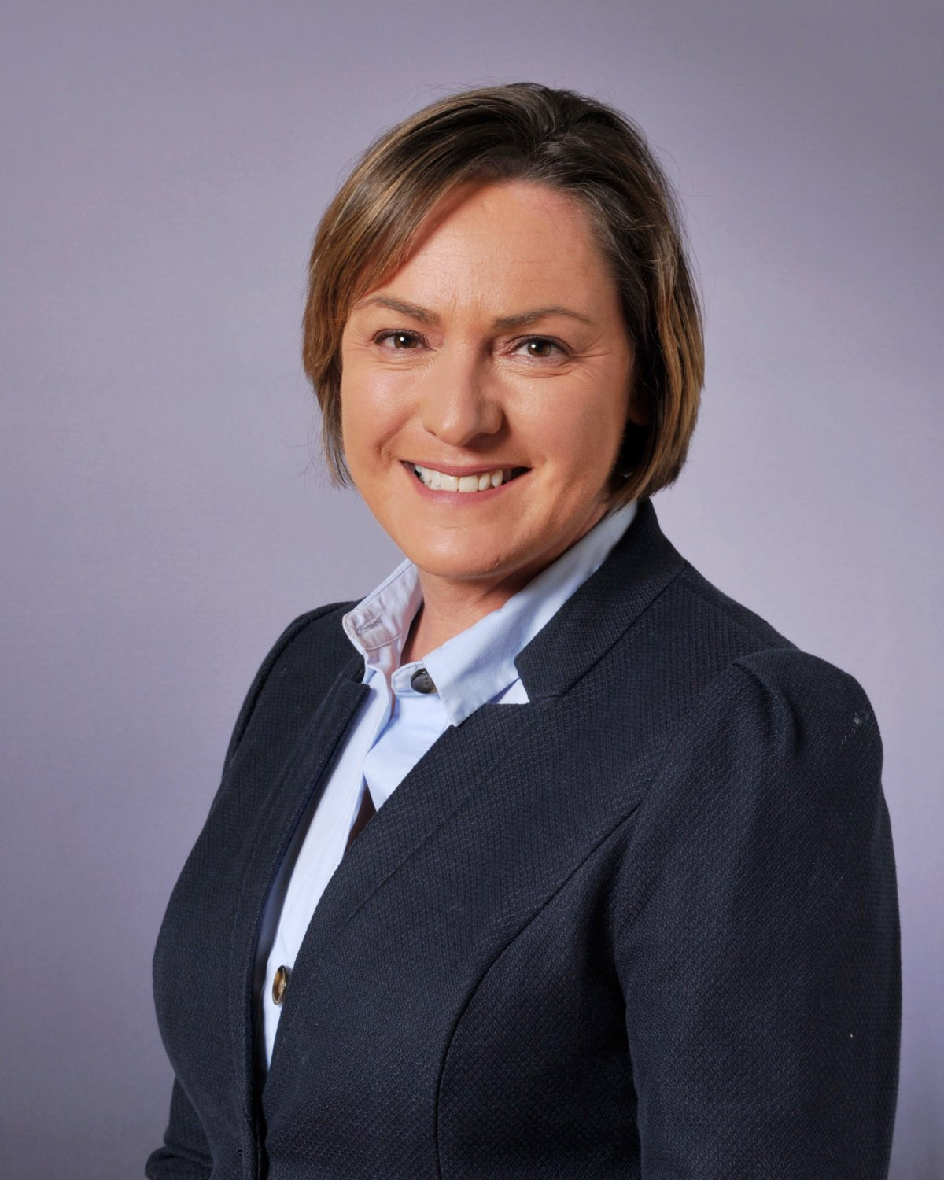



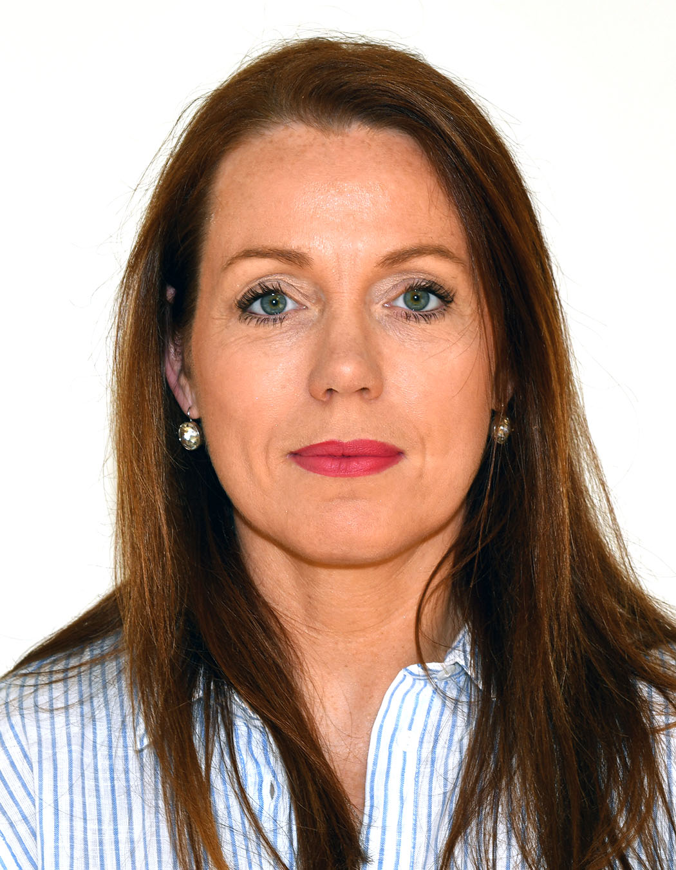

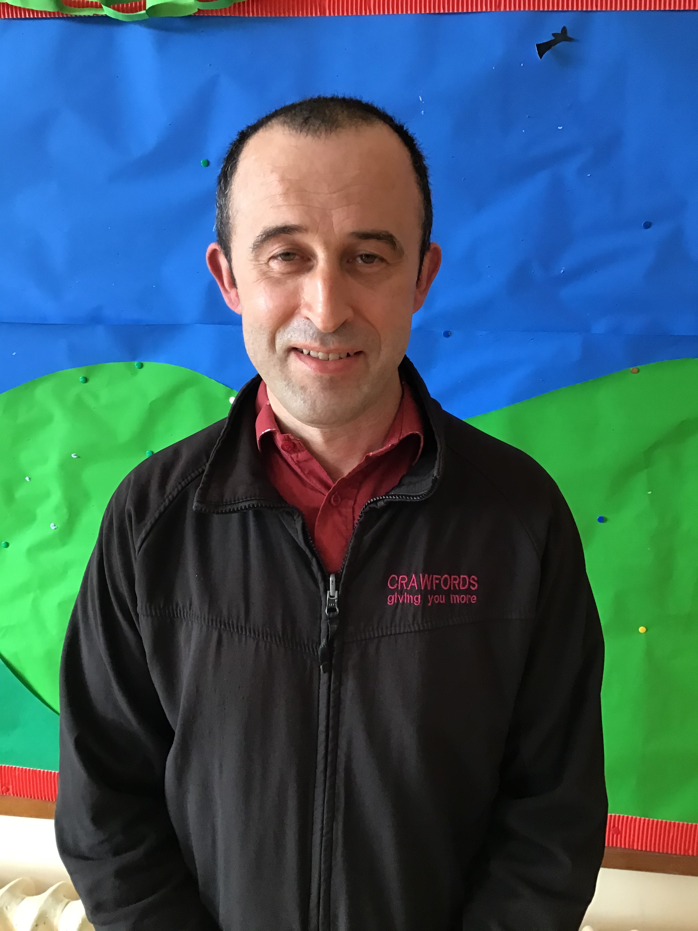

**Safeguarding Teachers**

**Safeguarding Governors**

**If you have a concern of a Child Protection nature, please speak to one us.**

**We care! We listen! We act!**