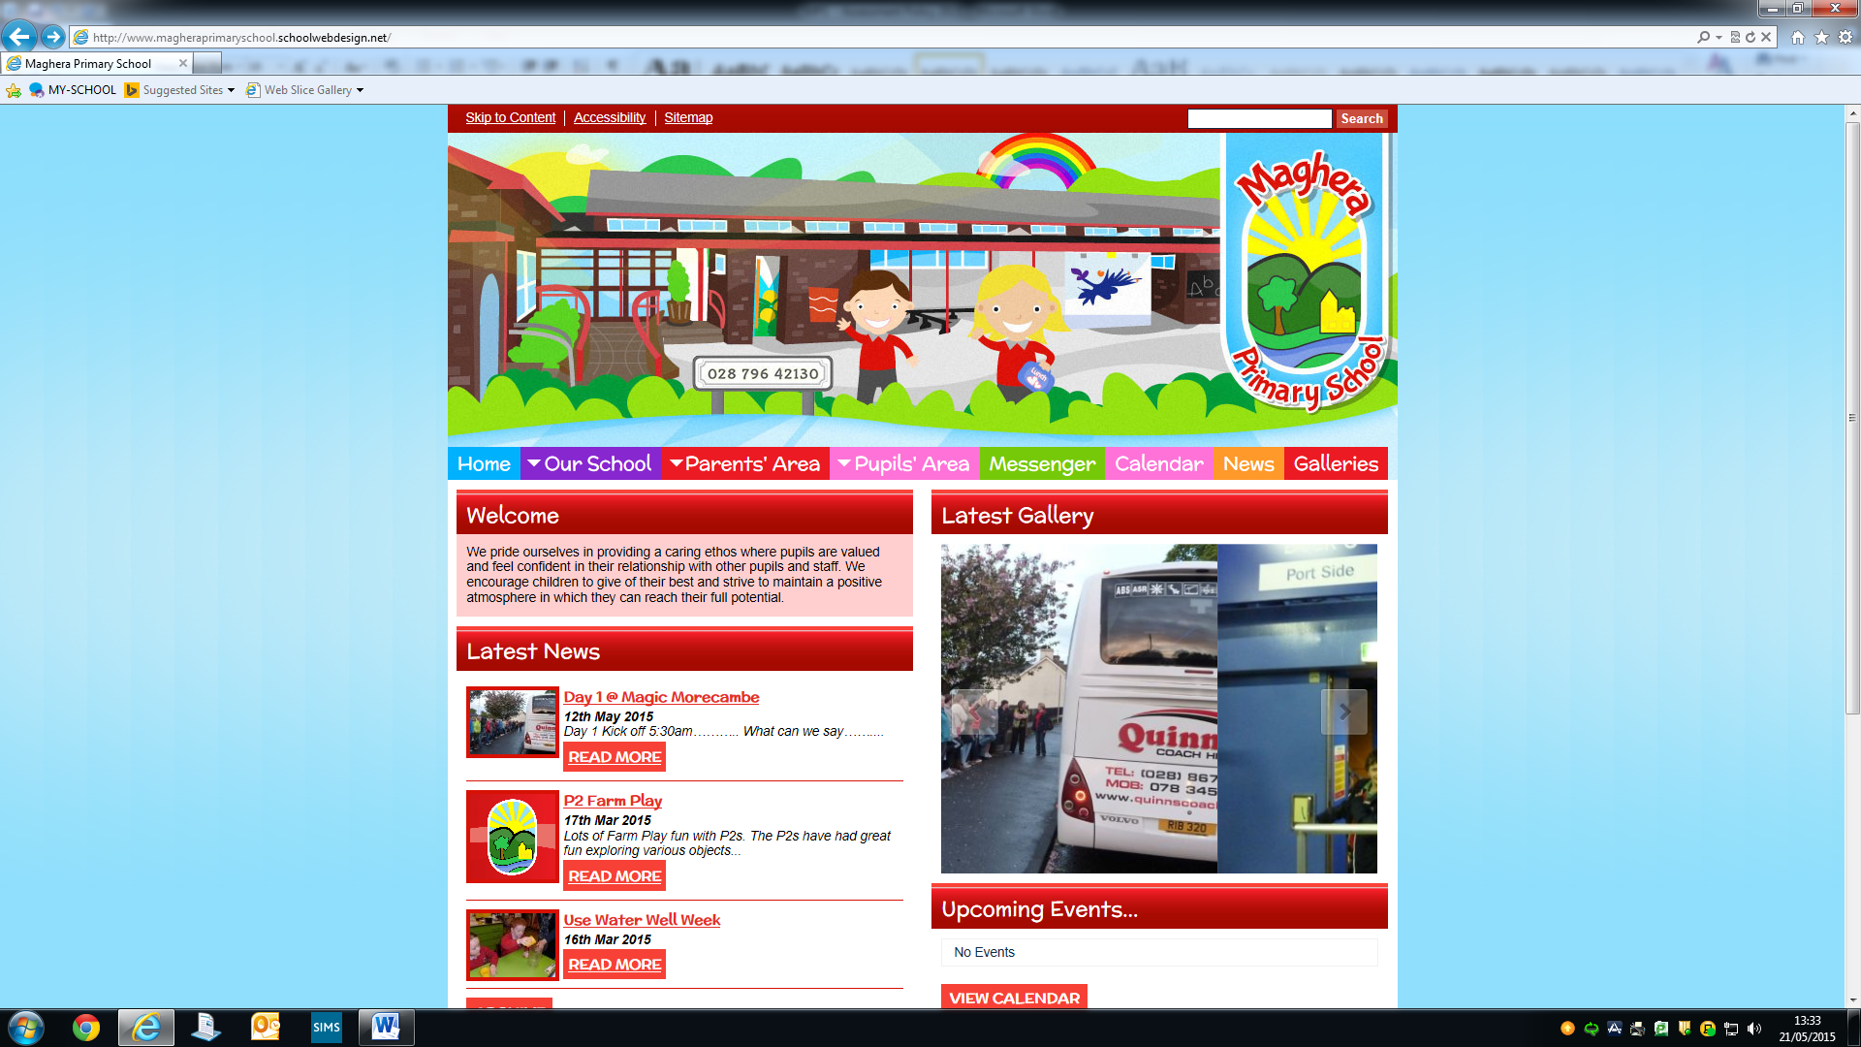

MAGHERA PRIMARY SCHOOL
15 Station Road, Maghera, Co Londonderry, BT46 5BS

E-mail: info@magheraps.maghera.ni.sch.uk
Website:www.magheraprimaryschool.com

Principal: Mrs L Mawhinney Tel: 028 796 42130

Reason for absence

MAGHERA PRIMARY SCHOOL
Absence Explanation Note

Please complete and return to the class teacher as soon as possible.

Name of Pupil: _____________________________

Class: ___________

Date (s) of Absence __________________________________

Reason for Absence: ___________________________________________________________________________________________________________________________________________________________________________________________________________________________

Signed: ____________________________ (Parent/Guardian)

Date: _____________________________

